Ridley Township Hometown Hero Banners

The Ridley Township Hometown Hero Banner Program is a living tribute created for the community to recognize and honor Veterans who are serving or have served our country in the United States Armed Forces.

To qualify, a Veteran, living or deceased, must have had a connection to Ridley Township (lives or lived in the township or is an immediate family member of someone who lives in the township). Also, those honored on war memorials within the community and Veterans recommended by Organized Veterans Groups, such as, Veterans of Foreign Wars, American Legion, Disabled American Veterans, Marine Corps League, Vietnam Veterans of America, etc.

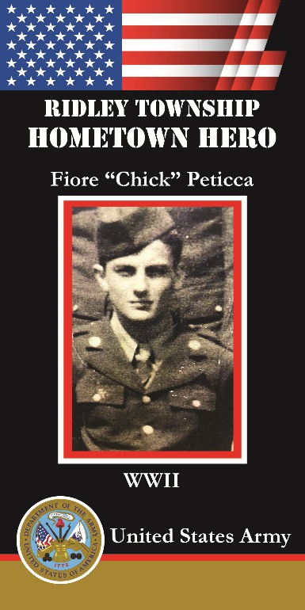

The banner will be 24”x48” heavy vinyl, printed the same on both sides, will display the service person’s photograph, include their full name, branch of the military, and the era of service (WWI, WWII, Vietnam, etc.). Banners will be displayed on a date to be determined and will be placed at the sole discretion of the Township.

Each banner requires the Hometown Hero Banner form to be filled out, a photograph of the Hero (preferably in uniform) and a payment of $125.00 for each banner, payable to: “Ridley Township Historical Society”; in the memo indicate “Hometown Hero”. Drop the check off or mail to Ridley Township, 100 E. MacDade Blvd., Folsom, PA 19033. The application can be downloaded from our website at www.ridleytwp.org.

Please note any awards such as Purple Heart, Silver Star or Bronze Star as notation will be included on the banner. To confirm an award or service details the veteran’s DD214 form can be accessed at: https://www.archives.gov/veterans/military-service-records

Businesses and civic organizations may also sponsor a banner for a particular veteran by filling out the sponsorship section of the form. Contributions toward the program will also be accepted.

Questions concerning qualification or application, contact Chrissy at hometownhero@ridleytwp.org or (610)534-4800.

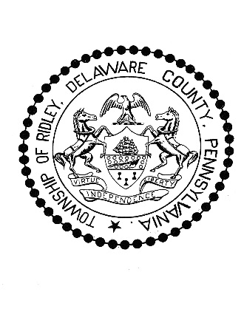

Ridley Township Hometown Hero
Banner Program Application

Full Name of Person in Photo: ___________________________________________________________________

Era of Service** (WWI, WWII, Vietnam, etc.):______________________________________________________

Branch of Military: ____________________________________________________________________________

Proof of Service (If Available): ___________________________________________________________________

Hometown: ___________________________________________

Is the Veteran: Alive__________ Deceased___________ KIA___________ POW/MIA___________

Name of Person/Business/Organization Submitting Photo: ____________________________________________________________________________________________

Relationship to Hometown Hero: _________________________________________________________________

Phone Number: _______________________________ Email: ________________________________________

Address: ____________________________________________________________________________________

Photo Release Statement:

I hereby grant the Ridley Township Hometown Hero Committee permission to use the attached photo (which includes a likeness of me, my relative, or person being sponsored) in the Hometown Hero Banner Program without payment of other considerations.

Signature Date

_______________________________________

Printed Name

**Era of Service
Global War on Terrorism September 11, 2001 – Present
Desert Storm January 17, 1991 – February 28, 1991
Persian Gulf August 2, 1990 – August 31, 1991

Vietnam February 28, 1961 – May 7, 1975
Korean Conflict June 27, 1950 – January 31, 1955
WWI April 6, 1917 – November 11, 1918
WWII December 7, 1941 – December 31 1946

Questions concerning qualification or application, contact Chrissy at hometownhero@ridleytwp.org or (610)534-4800.

